Support Planning Agency Selection User Manual

A step by step navigational process

November 2013

Prepared by: FEi Systems

Contents

1 Accessing SPA Selection 1

2 SPA Selection 2

2.1 Manual SPA Selection 2

2.2 Auto SPA Selection 3

2.3 Modify Effective Date of Pending SPA Selection 6

2.4 Discard SPA Selection 8

2.5 Archive SPA Selection 10

2.6 View Archived History 10

3 Assign Support Planner 11

3.1 Support Planner Assignment (Active SPA) 11

3.2 Support Planner Assignment (Pending SPA) 11

# Accessing SPA Selection

To access SPA selection, you must login as a permitted user:

1. Log in as the permitted user
2. Search for client under *Clients* tab using “**Case**” search
3. Click **Client Summary** for client

1. Enter client information and click "Cases" button
2. Click "Client Summary" link

1. Click **Support Planning Agency Selection (under Case Management)** from left navigation

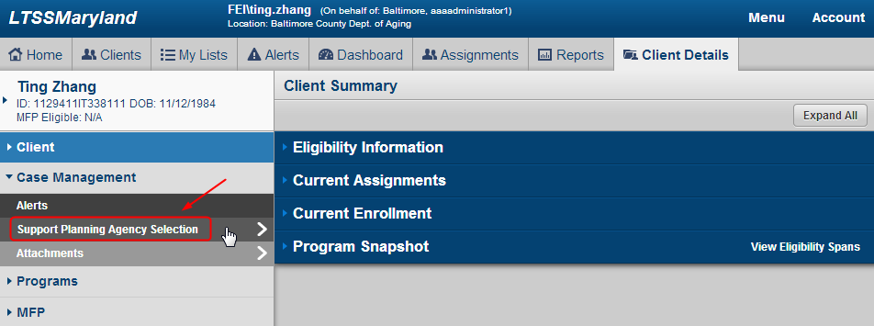

1. LTSS will bring you to SPA Selection - List Page

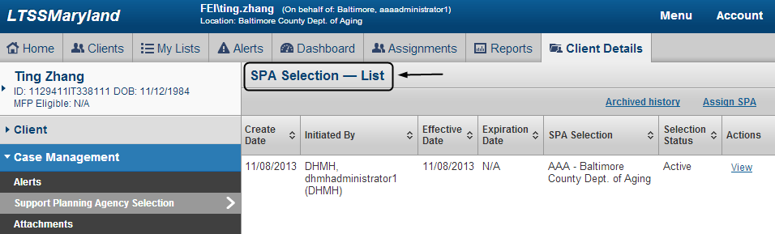

# SPA Selection

## Manual SPA Selection

To add a SPA Selection, you must login as a permitted user.

1. Access SPA Selection
2. Click “Assign SPA” from SPA Selection list page. *Please notes that LTSS will not you to make a new selection if previous selection became effective during last 45 days.*

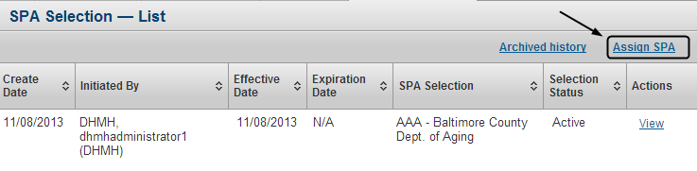

1. Complete SPA selection form and click “Assign”. *Please note that if you’re DHMH user, you can choose SPA from any jurisdiction; if you’re SPA user, you can only choose SPA from your jurisdiction.*

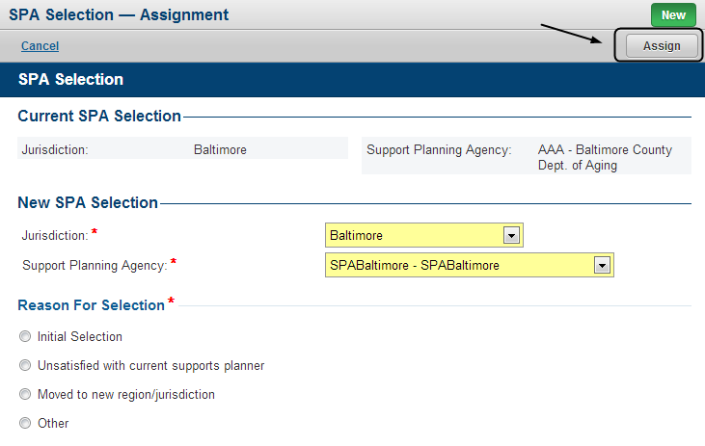

1. LTSS will prompt user to continue or cancel. Click “Submit” to continue selection, click “Cancel” to cancel

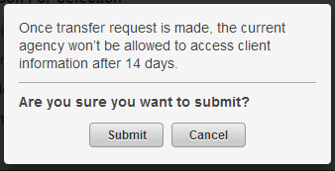

1. Once submitted, a new SPA selection is created. *Please note that if this is an initial selection, it will effective immediately; if the selection is made to replace current SPA selection, it will be pending for 14 days and effective after the pending period.*

## Auto SPA Selection

An auto SPA Selection will be made by following actions. *Please note that an auto SPA selection will only be made if client doesn’t have active SPA. An auto SPA selection will be pending for 21 days and effective after the pending period if no manual selection is made during the pending period.*

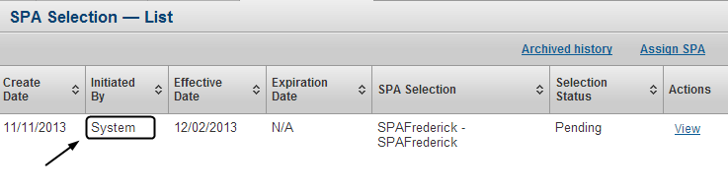

1. Submit CO/ICS Application Information

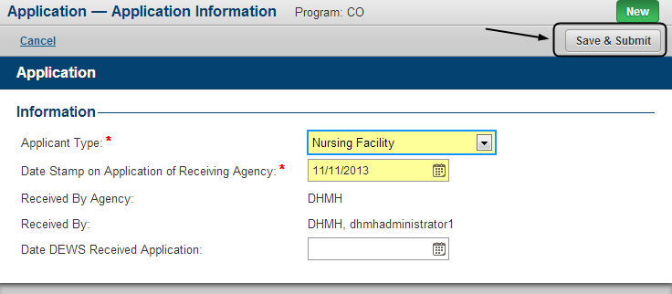

1. Submit MFP Options Counseling Form and answer “Yes” to question “Does the resident want application assistance for Community First Choice?”

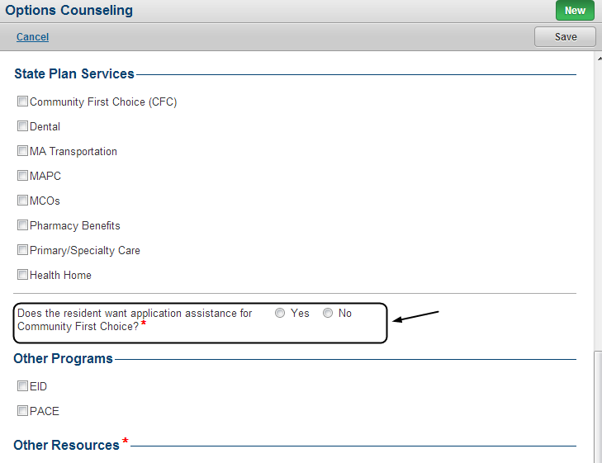

1. Submit MFP Options Counseling - Application Assistance Form and indicate that application assistance is provided for “Community Options”

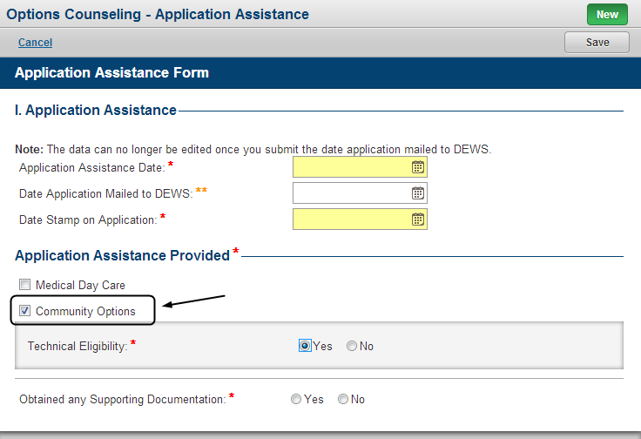

1. Submit interRAI HC MD Request and answer “Yes” to question “Was Support Planning Agency information packet sent to client?”

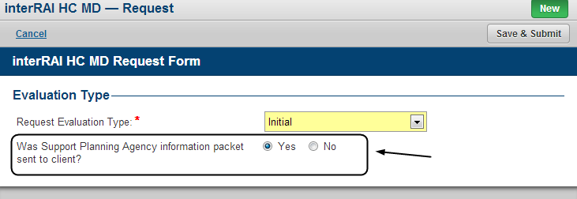

## Modify Effective Date of Pending SPA Selection

To modify effective data, you must login as permitted user and choose a **pending** SPA selection:

1. Access SPA Selection
2. Select a pending SPA selection and click “View”

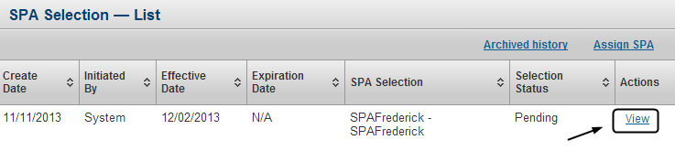

1. Click “Edit Effective Date”

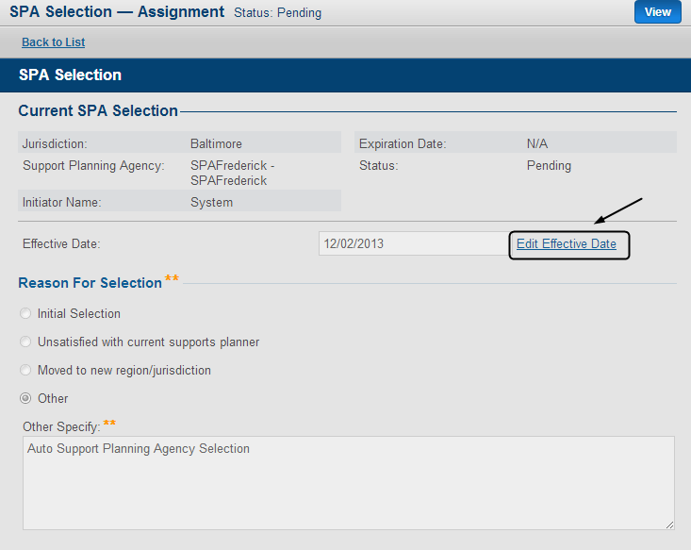

1. In the pop-up, Enter new effective date and reason for new effective date, then click “Save & Close”, you can also click “Cancel” to cancel

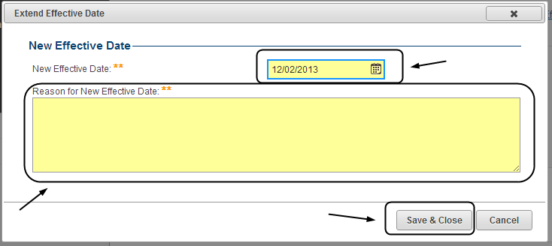

1. Effective date is changed

## Discard SPA Selection

To discard a SPA selection, you must login as permitted user and choose a **pending** SPA selection:

1. Access SPA Selection
2. Select a pending SPA selection and click “View”

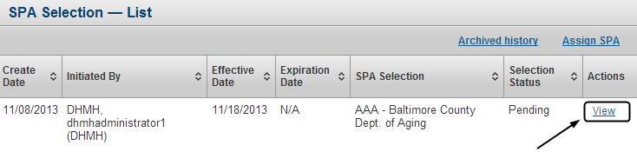

1. Click “Discard”

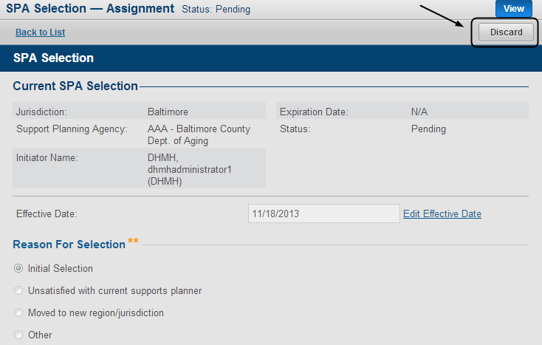

1. In the pop-up, click “Submit” to confirm discard, you can also click “Cancel” to cancel

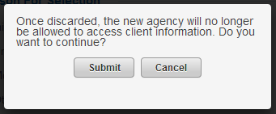

1. Enter “comments” and click “Yes” to complete discard, you can also click “No” to cancel

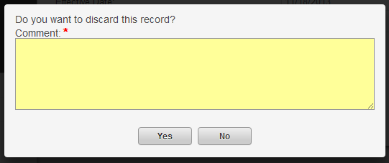

## Archive SPA Selection

To archive a SPA selection, you must login as permitted user and choose an **inactive** or **discarded** SPA selection:

1. Access SP Selection
2. Select an inactive or discarded record and click “Archive”

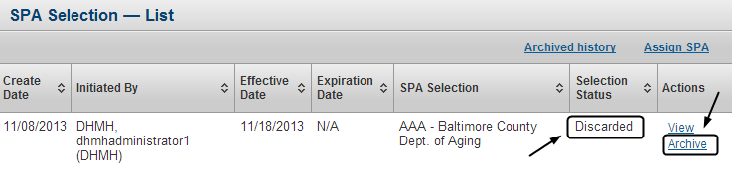

## View Archived History

1. Access SP Selection
2. Click “Archived History”

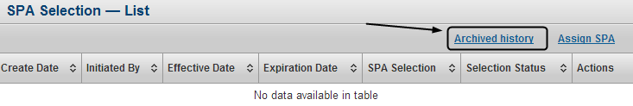

1. LTSS brings you to SPA Selection – Archived History. You can click “View” to view a record

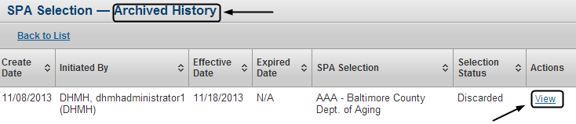

# Assign Support Planner

## Support Planner Assignment (Active SPA)

To assign support planner as active SPA, you must login as permitted user and your agency must be selected as active SPA by at least one client:

1. Click “Assignment Tab”



1. Click “Support Planner Assignment (Active)” from left navigation
2. Filter clients by “Unassigned” or “Assigned”
3. Select client(s)
4. Select support planner from “Assigned To” drop-down and click “Assign”

1. Filter clients by “Unassigned” or “Assigned”
2. Select client(s)
3. Select support planner from “Assigned To” drop-down and click “Assign”


1. Assignment is complete

## Support Planner Assignment (Pending SPA)

To assign support planner as pending SPA, you must login as permitted user and your agency must be selected as pending SPA by at least one client:

1. Click “Assignment Tab”



1. Click “Support Planner Assignment (Pending)” from left navigation
2. Filter clients by “Unassigned” or “Assigned”
3. Select client(s)
4. Select support planner from “Assigned To” drop-down and click “Assign”

1. Filter clients by “Unassigned” or “Assigned”
2. Select client(s)
3. Select support planner from “Assigned To” drop-down and click “Assign”


1. Assignment is complete